➊ Light and reflection 3

Light 3

Laws of reflection 3

Mirror image properties 3

➋ Refraction and total internal refraction 3

Refraction 3

Total internal reflection 4

Total internal reflection in daily life 4

➌ Lens and images 4

Types of lens 4

Images created by lens 4

Calculation of variables 5

➍ Particles and wave motion 5

Types of waves 5

Travelling wave 6

➎ Water waves 6

Reflection 6

Refraction 6

Diffraction 6

Interference 6

➎ Stationary waves 7

➏ Light waves 7

Young’s double slit experiment (YDSE) 7

Plane transmission grating 7

➏ Electromagnetic waves (EMWaves) 8

➐ Longitudinal waves 8

Displacement-distance graph (s-d) 9

Displacement-time graph (s-t) 9

➐ Mechanical waves 9

Wave nature of sound 9

Properties of sound 9

Musical sound properties 10

Book3 - Motion 10

Book3 - Force & Motion 11

Contact Force 11

Non-contact Force 11

Newton’s 1st law of motion 11

Newton’s 2nd law of motion 11

Weight & Mass 11

Fluid resistance 11

Newton’s 3rd law of motion 11

Formula database 12

Variable relativity 12

Units 12

**Physics**

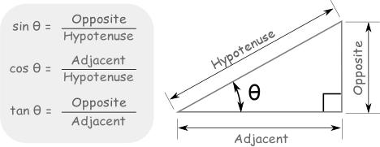Light speed = 3 · 108

1nm = 1 · 10-9 m

# 

# ➊ Light and reflection

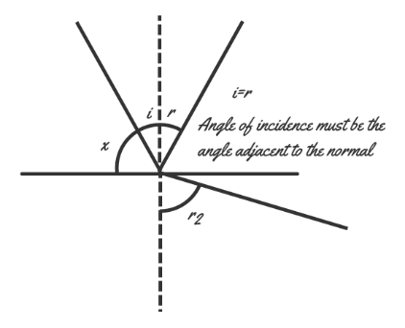Light

* Seeing = light from object towards eyes
* Near object 🡪 divergent rays
* Far object 🡪 ~parallel rays

Laws of reflection

* i = r
* on smooth surface - regular reflection
* 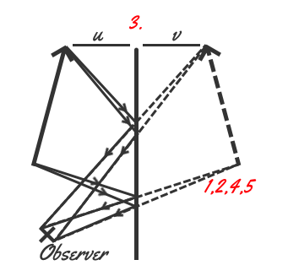on rough surface - diffused reflection // reflected in different directions

Mirror image properties

1. Behind the mirror
2. Virtual
3. v = u // (virtual and object distance)
4. Erect // same height
5. Laterally inverted

* Use ~△s to calculate mirror height and distance from ground.
* For question about a certain point in mirrors, use single lines.

# ➋ Refraction and total internal refraction

Refraction

* Dense = towards normal
* Less dense = away from normal
* n sin θ [/r] Refractive index (n), angle of refraction/incident (θ)
* n = c / v Refractive index (n), light speed (c), speed of light in medium (v)

v↑ v↓

Speed of light in air // Speed of light in vacuum is constant

* White light passes thru glass prism 🡪 dispersion
* White light = mixture of color
* For graph of ratio of refractive indexes of m 🡪

s1

s2

Sinθ1

Sinθ2

* Slope of s1 > s2 ∴ ns1 > ns2
* Slope of m > 1 = n1 > 2, Slope of m < 1 = n1 < 2 (Same for density)
* Note that s1&2 are different scenarios, while θ1&2 are in the same scenario
* 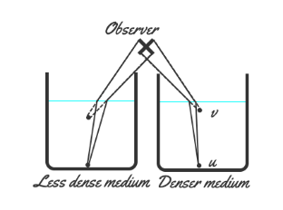For underwater images 🡪
* Virtual image formed at higher position
* Denser medium image formed at high+ position

Total internal reflection

* Denser → less dense medium //m1 density > m2 density
* i > C
* when i = C, r = 90° //total internal reflection doesn’t occur
* Refractive index (n), critical angle (C)

Total internal reflection in daily life

Optical fibers: cladding n < core n = total internet reflection // if the cladding n > core n, light in fiber would be refracted out

Optical fiber comparing to copper wire:

* Lighter
* Cheaper
* Less interference of signals

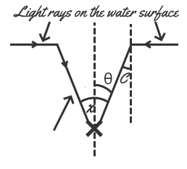Fish eye view: get ∠x: Find C, θ, where C = θ, multiply by 2

# ➌ Lens and images

Types of lens

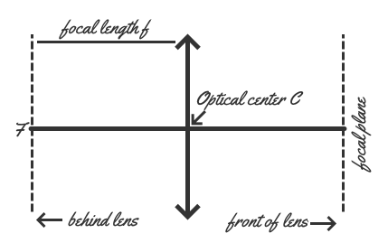Convex lens - bends inwards - converging lens

Concave lens - bends outwards - diverging lens

* Focal length (f) //distance between the focus and the lens
* Focus (F) //focus of the lens
* Optical center (C)

Images created by lens

Real image - capture on screen - convex lens

Virtual image - can’t capture - close convex lens, concave lens

f v b Focal length (f), image size (v), image brightness (b)

Properties of image:

* Real / virtual
* Magnified / diminished / unchanged
* Erect / inverted

When part of the lens is covered:

* Part of the light passes thru the lens
* Dimmer
* Full image

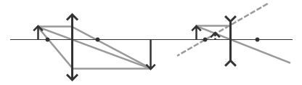Laws of drawing lens graph:

List of possible scenarios (vex): //the · represents the position of the image relative to the pos, there is no ·, object is @ pos

|  |  |
| --- | --- |
| Obj.location_infinity | F  ·2F | ·2F  2F | 2F  2F·F | 2F·  F | Img.location_infinity  F· | ·Obj | Flags: r - d - i  r - d - i  r - u - i  r - m - i  no image  v - m - e |

List of possible scenarios (cave): //the · represents the position of the image relative to the pos, there is no ·, object is @ pos

|  |  |
| --- | --- |
| Obj.location_infinity  2F·F | F· | Flags: VED  VED |

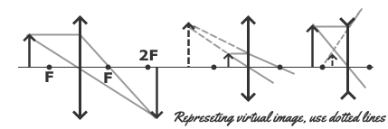

Calculation of variables

* Magnification (m), image distance (v), object distance (u)
* Image distance (v), object distance (u), focal length (f)

|  |  |  |  |
| --- | --- | --- | --- |
| Lens\var | focal length (f) | object distance (u) | image distance (v) |
| Vex | + | + | R+ V- |
| Cave | - | V- |

# ➍ Particles and wave motion

Types of waves

|  |  |  |
| --- | --- | --- |
| **Factors** | **Travelling wave** | **Stationary wave** |
| Movement | Moves forward | Doesn’t move from the location |
| Particle A | Particles vibrate with same A | Particles vibrates with diff A |
| Phases | Neighboring particles vibrate out of phase | Same loop = in phase, adjacent loop = antiphase |
| Max displaces | Particles reach @ diff times | Particles reach @ same times |
| Energy | Transmitted from one place to another | Not transmitted, stored in wave |

Travelling wave

λ

A

A

a c

b e

d

|  |  |  |
| --- | --- | --- |
| A | Amplitude | Half of a complete vibration | m |
| T | Period | Time for particle to make one complete vibration | s |
| f | Frequency | Number of vibrations in one second | Hz |
| λ | Wavelength | Distance between 2 success crests | m |
| v | Wave speed | Distance traveled in one second | ms-1 |

Assuming wave is moving to the left side

a momentarily at rest | d moving upwards | b moving downwards

ac in phase (distance in nλ, same y-level) | be out of phase | bd antiphase (distance in nλ.5)

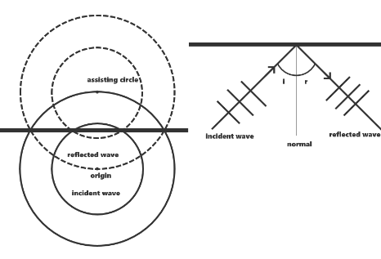

# ➎ Water waves

* Water waves can be observed in a ripple tank.
* w ∝ v
* ∆f / ∆λ wouldn’t affect v (v=f λ)
* The frequency of the dipper = f

Reflection

* Reflection of straight waves = reflection of light (v,f,λ unchanged)
* Drawing reflected wavefronts of waves 🡪

Refraction

* w v λ f (frequency remains unchanged)
* w Shallow region - wave bends towards
* w Deeper region - wave bends away
* Refractive index <·> … to … 🡪 n1>2 = v1 / v2 = λ1 / λ2

Diffraction

* Diffraction: v,f,λ unchanged
* θ d λ [/s] Angle of diffraction of water wave (θ), gap width (d), wavelength (λ)
* Refer to page 61 for details about sketching diffraction patterns

Interference

* Super position is the sum of the two pulses’ displacements.
* Constructive interference - path∆ = nλ // particles vibrate at a larger amplitude, particles are in phase
* Destructive interference - path∆ = nλ.5 // particles remain stationary, particles are antiphase
* Anti-nodal lines constructive, nodal lines destructive// clear concept: difference in constr/destr
* 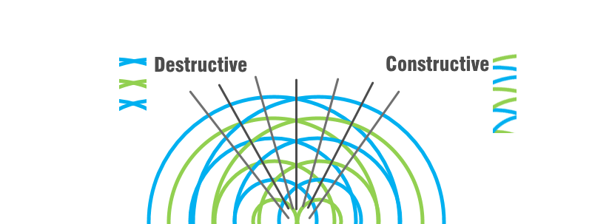θ d λ [/s] Spread of nodal lines (θ), separation of dippers (d), wavelength (λ)

# ➎ Stationary waves

Destructive

Constructive

* Results <·> interference of two waves w/ same f & A, traveling at same v in opposite ways
* Frequencies can only be multiples of the (f) of the first loop. (i.e. 2nd loop = 2f, 3rd = 3f)
* More loops ≠ higher speed
* When any particle is at max pos, all particle momentarily at rest

a

b

c

d

e

Assuming particle e is moving upwards

c stationary | de moving upwards | ab moving downwards

ab,de in phase (same loop) | ae,bd antiphase (adjacent loop)

# ➏ Light waves

* Diffraction of waves is only observable when d is comparable to the λ
* Bright fringe - constructive, Dark fringe - destructive
* Evidence that light is a wave: diffraction and interference

Young’s double slit experiment (YDSE)

* Pattern consisting of a series of evenly spaced fringes is produced
* Waves from the 2 slits: coherent (same f), similar A
* 2 slits mustn’t be too far, should be as narrow as possible
* Screen must be at a suitable distance (1~2m)
* Monochromatic light should be used (no white light)

700nm 400nm

1nm=10-9m Red:Violet λ

* ∆y D λ (d / a)
* ∆y = λD / a for D ≫ a
* a sin θ = nλ for D ≫ a
* Path difference at any position must be smaller than d // to get max number of n (p.139)

Plane transmission grating

* Fringes formed - brighter & spaced wider
* d = unit / lines
* d sin θ = nλ for largest n, d ≤ nλ n ≤ d/λ

Using white light,

* Central maximum = white
* Other maxima (max pos of the wave), color spectrums are formed
* Order of spectrum, width of spectrum
* Spectrum, inner edge = violet, outer edge = red 🡪
* Adjacent spectrums might overlap

# ➏ Electromagnetic waves (EMWaves)

* Transverse waves
* Do not require medium

v

f

* Vacuum speed = c 🡪
* Exhibit reflection, refraction, diffraction and interference
* Frequency being different prevents destructive interference occurring constantly at positions
* A star emits all kinds of EM waves

|  |  |  |  |
| --- | --- | --- | --- |
| **EM waves** | **Source** | **Use** | **Danger** |
| Radio waves | Radio transmitter | · Radio and tv broadcasts  · Telecommunication  · Transmit data |  |
| Micro waves  λ ↑ f ↓  λ↓ f ↑ | Microwave transmitter | · Microwave ovens  · Speed guns  · Radar (weather forecast / navigation)  · Satellite |  |
| Infra-red radiation | All objects | · Remotes  · Heat lamps  · Night vision goggles | Over heating |
| Visible light | Luminous object | · Vision  · Lasers (printers / pointers) | Damage retina |
| Ultra-violet radiation | Very hot objects | UV lamps | · Detection of fake banknotes  · Production of vitamin D in human body | Sunburn or cancer |
| X-rays | X-ray tube | · Medical imaging | cancer |
| Gamma rays | Radioactive substance | · Radiotherapy (kill cancer cells)  · Medical imaging | Cancer |

# ➐ Longitudinal waves

**λ**

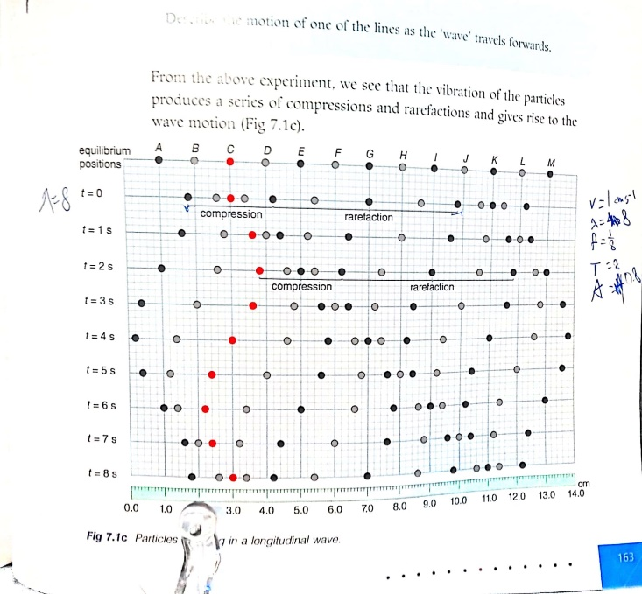

V 1 cm s-1 (v=fλ) (d/t, d=distance shift, t=used)

λ 8 cm (compression to compression)

f 1/T = 1/8

T 8 s (time to complete one particle cycle)

A 0.8 cm (largest displacement from e)

A

Rarefaction opposite direction

Center distance shifted

Compression same direction

T

Displacement-distance graph (s-d)

Showing particle’s displacement at the current time frame

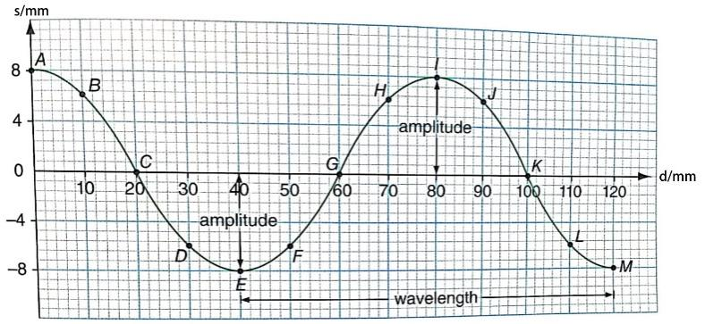Use to find a particle’s direction of travel

Displacement-time graph (s-t)

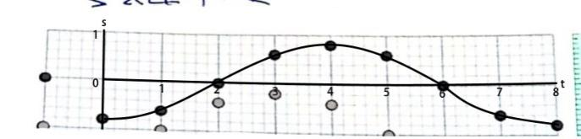Showing a particle’s displacements at different times

# ➐ Mechanical waves

Wave nature of sound

* Sound source vibrates, air particles nearby vibrate together
* Sound is a longitudinal wave
* Sound can’t travel without a medium
* Sound can reflect, refract, diffract and have interference (Sound is a wave)
* Loud sound - constructive, soft sound - destructive (Background noise)
* 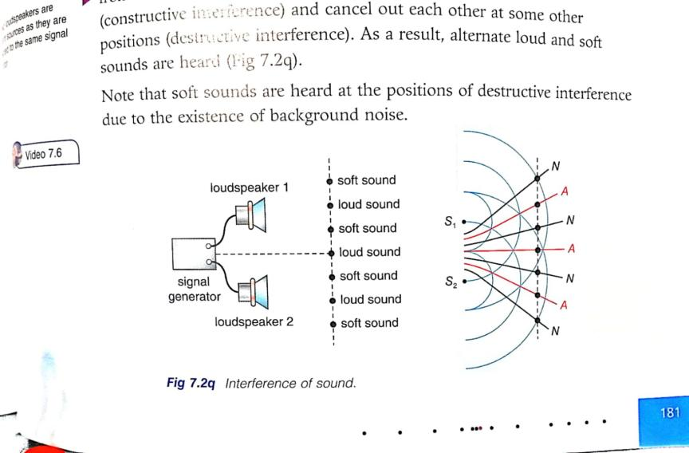Noise cancelling headphones produces antiphase audio to create destructive interference to reduce the noise

Properties of sound

* Sound speed: solid > liquid > gas
* Same medium but hotter allows sound to be travelled faster
* Air travel speed 340 ms-1
* Audible frequency range (can be heard) is 20Hz - 20000Hz
* Infrasound ≤ 20 Hz ≤ 20kHz ≤ Ultra sound (used for scanning)
* Echo of sound allows people to determine a certain distance
* Further away = lower volume

Musical sound properties

* Note = regular vibrations
* Noise = irregular vibrations
* A Loudness
* λ Pitch f
* different qualities = different instruments
* sound intensity level (dB), 0dB ≠ no sound
* 140dB 🡪 permanent damage to ears, irritated, stressed
* Protect ears from excessive noise with acoustic protection

# Book3 - Motion

SI Unit: metre, second

Distance = Path distance [magn]

Displacement = Direct distance [magn, dir] //start pos = finish pos : displacement = 0

Acceleration: Change in velocity over time

Avg Speed = [magn, {}]

Avg Velocity = [magn, {}]

// Instantaneous Speed = Average speed at an instance : Instantaneous speed & velocity = same magnitude

Avg Acceleration = [magn, {}]

//Same sign -> Speed up : Opposite sign -> Slow down

s-t graph

Slope : v

Flat : v = 0

v-t graph

Slope : a

Area : total s

Flat : moving @ constant v

Δ PosNeg : Δ direction

a-t graph

Flat = speeding up constantly

Motion tools: Motion sensor → positive = away from sensor

* For v=velocity, a=acceleration, t=time, s=displacement, u=initial velocity
  + (s)
  + (a)
  + (v)
  + (t)

# Book3 - Force & Motion

SI Unit: Newton N

Force exist in pairs

Contact Force

1. Friction

Opposite to relative motion

1. Tension

Along the rope, same magn @ every point

1. Normal

⊥ to surface

Non-contact Force

1. Weight

Vertically downwards

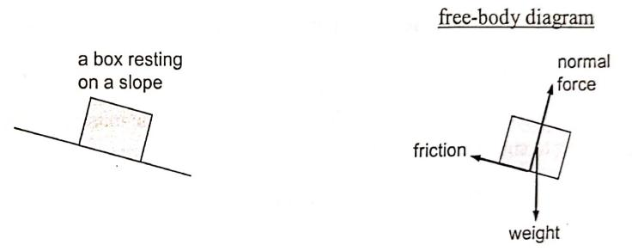

Newton’s 1st law of motion

* SI Unit: Mass kg
* Inertia is the tendency of an object to maintain its state of rest / constant v
* Sol: When #obj# accelerates, #item# remains in a state of rest due to inertia.

Newton’s 2nd law of motion

* F=ma
* On a smooth surface && moving: F = Force - friction
* On a smooth surface && stationary: F = friction - Force
* When 2 items are connected with string: m = net mass
* On a pulling force: F = Force - tension

Weight & Mass

* W=mg

Fluid resistance

* An object experiences resistance force when it moves through fluids //non-solids
* Speed ↑ : fluid resistance ↑
* Speed 0 : fluid resistance 0
* Like friction

Newton’s 3rd law of motion

# Formula database

Distanced traveled (d), speed (v), time elapsed (t)

i = r Angle of incident (i), angle of reflection (r)

n sin θ [/r] Refractive index (n), angle of refraction/incident (θ)

Refractive index (n), light speed (c), speed of light in medium (v)

Refractive index (n), critical angle (C)

Magnification (m), image distance (v), object distance (u)

Image distance (v), object distance (u), focal length (f)

f = T-1 Frequency (f), Period (T)

v = fλ Frequency (f), wave speed (v), wavelength (λ)

Refractive index <·> medium 1 to 2 (n1>2), wave speed (v), wavelength (λ)

Fringe separation (∆y), wavelength of light (λ), distance <·> double slit (D), slit separation (a) // for D ≫ a

a sin θ = nλ Slit separation (a), angular position of the nth-order bright fringe (θ), nth bright fringe (n), wavelength of light (λ) // for D ≫ a

d = unit / lines grating spacing (d), lines per unit.

d sin θ = nλ grating spacing (d), angular position of the nth-order bright fringe (θ), nth bright fringe (n), wavelength of light (λ) //for max n, n ≤ d/λ

(s) velocity (v), acceleration (a), time (t), displacement (s), initial velocity (u)

(a) velocity (v), acceleration (a), time (t), displacement (s), initial velocity (u)

(v) velocity (v), acceleration (a), time (t), displacement (s), initial velocity (u)

(t) velocity (v), acceleration (a), time (t), displacement (s), initial velocity (u)

F=ma Net force (F), mass (m), acceleration (a)

# Variable relativity

p n C v Density of medium (p), refractive index (n), critical angle (C), speed of light (v)

f v b Focal length (f), image size (v), image brightness (b)

Red:Violet λ Wavelength of light (λ), defined values (violet:red)

w v Water depth (w), wave speed (v)

f λ Wave frequency (f), wavelength of wave (λ)

w v λ f Water depth (w), wave speed (v), frequency (f), wavelength (λ)

θ d λ Angle of diffraction of water wave (θ), gap width (d), wavelength (λ)

θ d λ Spread of nodal lines (θ), separation of dippers (d), wavelength (λ)

∆y D λ (d / a) Fringe separation (∆y), wavelength of light (λ), distance <·> double slit or grating (D), slit or fringe separation (a)

A Loudness height Amplitude (A), loudness of sound

Width λ Pitch f Wavelength (λ), pitch of sound

# Units

1nm = 10^-9m 10^-6mm

1mm=10^-3m 10^6nm

1cm=10^-2m